Build a data structure that can contain currency conversion ratios based with example/dummy data for:

* GBP to USD
* GBP to AUD
* GBP to EUR

Create a front-end application using the technology and language of your choice that:

* Allows the user to specify an amount to convert between any of the currencies in the above list
* Provides sensible validation on user inputs

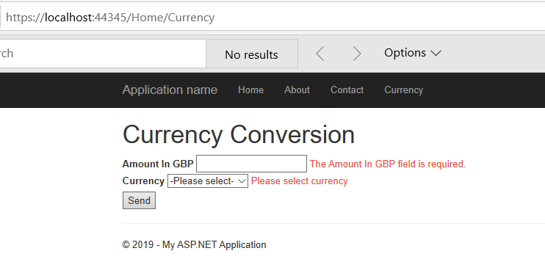

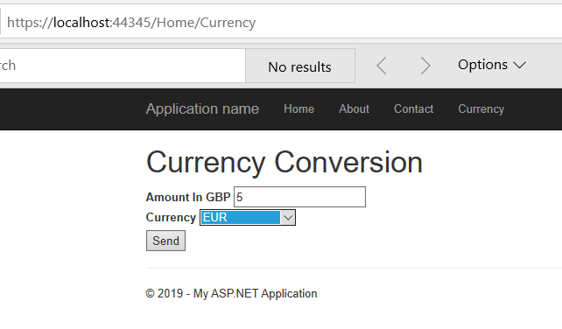

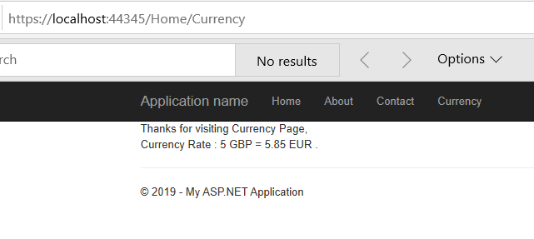

Next, create a data structure that allows currency conversions made by the user to be logged for audit purposes.

Create an interface that allows the currency conversion audit to be queried within a user-specified date range.

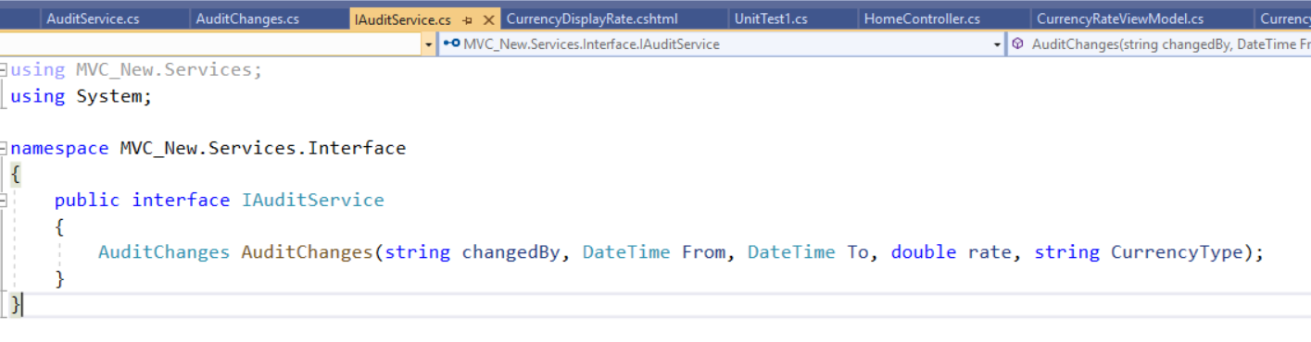

Please apply solid principles and show all TDD (Test Driven Development).

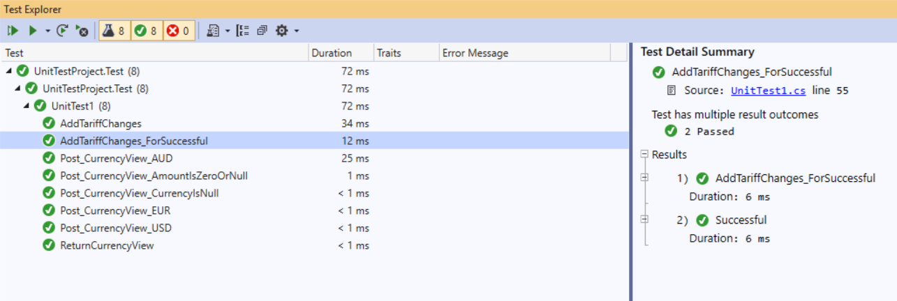

**Please Note**

Upon completion, ensure you zip up the files, include any relevant documentation and then upload this to google drive or GIT and share the link with me so that I can download the file and pass it along to our development team for review.

You will receive feedback on your tech-test during your interview.